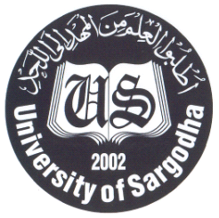
University of Sargodha

Corrigendum

The following amendment is notified in the advertisement published in daily Jang and The Nation dated: 15-7-2018, daily Pakistan dated: 16-07-2018 vide IPL-7341 and on PPRA website.
- The revised date of submission of Proposal is 17-08-2018.

Other terms and conditions will remain the same. For further details please contact at phone no 048-9230537/0300-4986688.

Chairman Consultant Selection Committee

