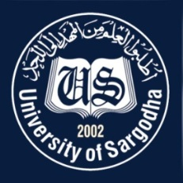 | Faculty Positions on Visiting Basis
Department of Communication & Media Studies
University of Sargodha
Applications for the following positions are invited from Pakistani nationals for Spring semester 2021
Teaching Faculty

Sr.# | Positions | Nature of Post |  | Eligibility Criteria
1. | Visiting Faculty | Visiting Faculty  (Open merit, for Spring Semester 2021). |  | Qualification:-  - Ph.D in relevant field for Assistant Professor & Above  - MS / M.Phil in relevant field for Lecturer
NOTE |  |  | General Information
- As per university policy, the department reserves the right not to consider any application or fill any post without giving any reason.
- Candidates are required to submit complete C.V and attested copies of testimonials along with
duly filled application form in the Department Office.
- Prescribed application form may be downloaded from university website
(https://www .uos.edu .pk/admin Forms)
- Applications complete in all respects should reach the Department (by hand, post or through
e-mail) on or before09-02-2021.
- Interview of the short-listed candidates will be conducted on 17-02-2021 (at10:00 am) in the office of In-charge, Communication & Media Studies, Sargodha University
- Only short listed candidates will be called for interview.
- The applicants having provisional transcript will not be eligible for the visiting faculty
- Applications received after due date will not be entertained.
- Candidates with relevant experience will be preferred.
- Applications should be addressed to In-charge, Communication & Media Studies, University of Sargodha.

In-charge
Communication & Media Studies
University of Sargodha.
E-mail: communicationstudies@uos.edu.pk

