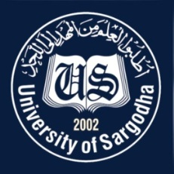 | Faculty Positions on Visiting Basis
Department of Statistics
University of Sargodha
Applications for the following positions are invited from Pakistani nationals for Spring semester 2022.
Teaching Faculty

Sr.# | Positions | No. of Posts | Nature of Post | Eligibility Criteria
1. | Visiting Assistant Professors/Lecturers  Statistics | 20 | Visiting Faculty  (Open merit, for Spring Semester, 2022). | Qualification:-  - PhD in Statistics/BioStatistics for Assistant Professor  - M.Phil, in Statistics/ BioStatistics for Lecturer
NOTE |  |  | General Information
- As per university policy, department reserves the right not to consider any application or fill any post without giving any reason.
- Candidates are required to submit complete latest C.V, two latest Passport Size Pictures and attested copies of all testimonial documents along with duly filled application form in the Office of Department of STATISTICS, Sargodha University.
- Prescribed application form may be downloaded from university website (https://www.su.edu.pk/forms)
- Applications complete in all respects should reach the department on or before 14-02-2022.
- Demonstration / Interview of all candidates will be conducted on 15-02 -2022 (at 10:00 am) in the office of Chairman, Department of Statistics, Sargodha University.
- The applicants having provisional transcript will not be eligible for the visiting faculty
- Applications received after due date will not be entertained.
- Candidates with relevant experience will be preferred.
- Online applications will not be accepted.
- Posts can be increased or decreased according to the requirement of subjects.
- No TA/DA will be admissible.

Chairman
Department of Statistics
University of Sargodha

